

ITL704 ROSP LAB

Mini Project Report

Title of the Project:

SnX: 3D Outfit Customizer

YAMIN KHAN

Supervisor/Guide:

ER. FARDEEN SHAIKH



Academic Year (2026-27)

CERTIFICATE

This is to certify that the project entitled “SnX: 3D Outfit Customizer” is a bona fide work of “Yamin Khan” (242464), “Abdurrahman Qureshi” (242466), “Mohammed Rumaan Shaikh” (242469) and “Abdul Sameer Shaikh” (242471) submitted to the University of Mumbai in partial fulfillment of the requirements for the ITL704 Mini Project for Recent Open-Source Project of 7th Semester in Department of Information Technology.

(ER. FARDEEN SHAIKH) (Dr. Zainab Mirza)
Supervisor/Guide Head of Department

MINI PROJECT REPORT APPROVAL

This project report entitled “SnX: 3D Outfit Customizer” is a bona fide work of “Yamin Khan” (242464), “Abdurrahman Qureshi” (242466), “Mohammed Rumaan Shaikh” (242469) and “Abdul Sameer Shaikh” (242471), is approved for the ITL704 Mini Project for the Recent Open-Source Project Lab project for the 7th semester.

Examiners:
______________________ (Internal Examiner)

______________________ (External Examiner)

Date :

Place : Mumbai

DECLARATION

We declare that this written submission represents my ideas in my own words and where others’ ideas or words have been included, I have adequately cited and referenced the original sources. I also declare that I have adhered to all principles of academic honesty and integrity and have not misrepresented or fabricated or falsified any idea/data/fact/source in my submission. I understand that any violation of the above will be cause for disciplinary action by the Institute and can also evoke penal action from the sources which have thus not been properly cited or from whom proper permission has not been taken when needed.

Yamin Khan (242464)

- Abdurrahman Qureshi (242466)

- Mohammed Rumaan Shaikh (242469)

- Abdul Sameer Shaikh (242471)

Date :

ABSTRACT

The SnX: 3D Outfit Customizer is an interactive web-based platform designed to enhance the online fashion shopping experience by enabling users to create, personalize, and visualize outfits in a three-dimensional virtual environment. Traditional online fashion platforms primarily rely on static two-dimensional images and predefined clothing options, which limit users' ability to explore their creativity and accurately visualize how different clothing elements complement one another. SnX addresses these limitations by integrating 3D modeling, interactive customization, and personalized recommendations into a unified platform.

The proposed system utilizes modern web technologies including ReactJS, Next.js, MongoDB, React Three Fiber, and Three.js to provide an immersive and responsive user experience. Users can explore a collection of clothing items, fabrics, colors, patterns, and accessories and customize various outfit elements such as sleeves, collars, hemlines, and other design features. The 3D visualization environment allows users to interact with and preview their customized outfits in real time, providing a more realistic representation than conventional 2D-based shopping platforms. MongoDB is used for efficient storage and retrieval of user preferences, customization choices, and personalized results.

In addition to 3D customization, the system incorporates a personality-based recommendation approach using Holland's career personality model to analyze user responses and generate personalized outfit recommendations. The system evaluates user preferences and stores the resulting profiles and recommendations for future reference. Through the integration of interactive 3D visualization, personalization, and user-friendly design, SnX aims to provide a more engaging, creative, and individualized fashion experience. Although challenges such as realistic 3D rendering, accurate fabric texture representation, device compatibility, and website performance may arise, the proposed system demonstrates the potential of 3D technologies to transform conventional online fashion shopping into a more immersive and personalized digital experience.

TABLE OF CONTENTS

Sr. No. | Content | Page No.
 | Abstract
2. | Introduction
3. | Literature Survey
4. | Methodology
5. | Design / Implementation
6. | Hardware and Software Requirements
7. | Testing / Result and Analysis
8. | Snapshots
9. | Open Source Contributions
10. | Timeline Chart
11. | Future Scope
12. | Conclusion
13. | References

INTRODUCTION

1.1 PROJECT OVERVIEW
Online fashion shopping has become increasingly popular, but most platforms still rely on static images and predefined clothing options. This limits users' ability to personalize outfits and visualize how different clothing items, colors, patterns, and accessories will look together.

SnX: 3D Outfit Customizer is a web-based platform designed to provide an interactive and personalized fashion experience through 3D outfit customization. Users can select clothing items, colors, patterns, fabrics, and accessories and visualize their customized outfits in a 3D environment. This allows users to experiment with different designs and create outfits according to their preferences.

The system is developed using technologies such as ReactJS, Next.js, Three.js, React Three Fiber, and MongoDB. Three.js and React Three Fiber are used for 3D visualization, while MongoDB manages user preferences and customization data. The system also provides personalized outfit recommendations based on user preferences and Holland's personality model.

Overall, SnX aims to make online fashion shopping more interactive, creative, and personalized by combining 3D visualization with customization and recommendation features.

1.2 PROBLEM STATEMENT

1.2.1 Problem Definition
Existing online fashion shopping platforms mainly provide predefined clothing options with static 2D images. Users have limited control over customizing outfits according to their personal preferences and may find it difficult to visualize the final appearance of different clothing combinations.

The absence of an interactive 3D customization environment reduces user engagement and limits creative expression. Therefore, there is a need for a platform that allows users to design, customize, and visualize outfits in a 3D environment while providing a personalized shopping experience.

1.2.2 Proposed Work
The proposed SnX: 3D Outfit Customizer aims to provide an interactive web-based platform where users can create and personalize outfits using 3D models. Users can select and customize clothing items such as shirts, trousers, shoes, and caps, along with colors, backgrounds, decals, images, and text.

The system also allows users to save their customized models, retrieve recent designs, and export the final models in PNG or GLB format. Personalized recommendations based on user preferences are also provided to enhance the overall experience.

1.2.3 Proposed Methodology
The proposed system follows an Agile development approach, where the application is developed and tested incrementally. The system consists of a user interface, 3D visualization module, database, and recommendation features.

ReactJS and Next.js are used for the web interface, while Three.js and React Three Fiber are used for 3D visualization and customization. MongoDB is used to store user information, preferences, and saved models. The developed modules are integrated and tested to ensure proper functionality and a smooth user experience.

1.3 OBJECTIVES AND SCOPE

1.3.1 Objectives
The main objectives of the SnX: 3D Outfit Customizer are:
- To develop an interactive platform for 3D outfit customization.
- To allow users to create outfits according to their personal preferences.
- To provide realistic and interactive 3D visualization of customized outfits.
- To provide different clothing items, colors, styles, and customization options.
- To allow users to save, retrieve, reset, and export customized models.
- To provide personalized outfit recommendations based on user preferences.
- To develop a simple and user-friendly interface.
- To enhance creativity and engagement in online fashion shopping.

1.3.2 Scope
The scope of the project includes the development of a web-based platform with the following features:

- User registration and authentication.
- 3D customization of clothing items such as shirts, trousers, shoes, and caps.
- Customization of colors, background, size, decals, images, and text.
- Creation of new outfits and modification of recent models.
- Saving customized models and user preferences in the database.
- Exporting customized models in PNG and GLB formats.
- Personalized outfit recommendations.
- Profile and feedback management.

The project focuses on providing a simple, interactive, and personalized 3D fashion customization experience. Advanced features such as AR-based virtual try-on, highly realistic fabric simulation, and large-scale e-commerce integration can be considered as future enhancements.

2. LITERATURE SURVEY

2.1 INTRODUCTION
The literature survey for the SnX: 3D Outfit Customizer focuses on existing research related to interactive 3D web environments, modern web application development, 3D rendering, and technologies used for developing interactive user interfaces. The survey includes research papers related to ReactJS, Next.js, Node.js, WebGL, Three.js, and MERN-based applications.

Existing research indicates that 3D web environments can provide a more engaging and visually appealing experience compared to traditional 2D interfaces. However, research also highlights challenges related to usability, performance, rendering quality, device compatibility, and efficient handling of 3D models. These findings provide a foundation for designing SnX as an interactive and user-friendly 3D customization platform

2.2 RESEARCH PAPERS
Paper 1: Dual-Mode User Interfaces for Web-Based Interactive 3D Virtual Environments Using Three.js
Authors: Matthew Stanton, Thomas Hartley, Fernando Loizides, and Adam Worrallo
Published: 2017
The research compares 2D, 3D, and dual-mode interfaces for web-based virtual environments. The study indicates that 3D interfaces provide better visual appeal, while 2D interfaces offer better information presentation and retrieval. The research suggests that combining 2D and 3D interfaces can improve user interaction. This concept is relevant to SnX, where 3D visualization can be combined with conventional interface elements to improve usability.

Paper 2: React JS – An Emerging Frontend JavaScript Library
Authors: Pratik Sharad Maratkar and Pratibha Adkar
Published: 2021
The paper discusses ReactJS and its component-based architecture, Virtual DOM, JSX, and one-way data flow. ReactJS supports the development of reusable and interactive user interfaces. These features make it suitable for applications that require frequent UI updates and user interaction, such as the SnX outfit customization platform.

Paper 3: React Apps with Server-Side Rendering: Next.js
Authors: Harish A. Jartarghar et al.
Published: 2022
This research examines the use of Next.js with ReactJS for web application development. It highlights server-side rendering as a method for improving page loading and application performance. Next.js also provides automatic routing and SEO benefits. These features support the development of a responsive and efficient SnX web application.

Paper 4: Survey and Analysis of Rendering Realtime 3D Object on Cross-Browser & Cross Platform Using WebGL
Authors: Yogiraj Patil and Kirti Wanjale
Published: 2020
The paper focuses on real-time 3D object rendering using WebGL and JavaScript. It discusses challenges associated with rendering 3D objects across different devices, screen sizes, and processing capabilities. The research also highlights the importance of optimized rendering and efficient 3D formats such as glTF. These findings are relevant to SnX because the platform requires efficient browser-based rendering of customizable 3D models.

Paper 5: Efficient Visualization of 3D Models by Web Browser
Authors: Bartosz Sawicki and Bartosz Chaber
Published: 2013
The research presents a JavaScript-based approach for displaying 3D models in web browsers, with particular attention to mobile devices and network efficiency. The study explores progressive mesh streaming and server-side rendering approaches. The findings demonstrate the importance of efficient 3D model visualization for browser-based applications.

Paper 6: The Research and Design of 3D Web Guide System Based on WebGL
Author: Cui Peng
Published: 2021
The paper presents an interactive 3D web system developed using WebGL, Three.js, Node.js, and Socket.IO. The system demonstrates how web technologies can be combined to create interactive 3D environments. This research supports the use of Three.js and related technologies for developing interactive 3D applications such as SnX.

Paper 7: Performance Optimization using MERN Stack on Web Application
Authors: Sourabh Mahadev Malewade and Archana Ekbot
Published: 2021
The research examines the development of an e-commerce web application using the MERN stack, consisting of MongoDB, Express.js, React.js, and Node.js. It highlights the benefits of ReactJS for user interfaces and Node.js for asynchronous server-side operations. The study provides relevant insights into using modern JavaScript technologies for developing interactive web applications.

2.3 SUMMARY OF LITERATURE SURVEY
The reviewed studies demonstrate the potential of modern web technologies for developing interactive 3D applications and user-centric web platforms. Research on ReactJS and Next.js highlights their suitability for developing responsive and component-based interfaces, while studies on WebGL and Three.js demonstrate their capability for browser-based 3D visualization. Research on MERN-based applications further supports the use of modern JavaScript technologies and database systems for interactive web applications.

However, the reviewed studies primarily focus on individual aspects such as 3D rendering, frontend development, web application performance, or general 3D interaction. There is comparatively less focus on combining these concepts into a personalized fashion platform that allows users to customize and visualize complete outfits.

Therefore, SnX: 3D Outfit Customizer builds upon these existing concepts by combining 3D visualization, outfit customization, modern web development, database management, and personalization into a single platform. This provides the basis for developing an interactive and user-friendly solution for personalized digital fashion experiences.

3. METHODOLOGY

3.1 INTRODUCTION
The SnX: 3D Outfit Customizer follows a systematic software development methodology to design and implement an interactive 3D fashion customization platform. The methodology defines the system architecture, functional components, data flow, user interaction, and technologies required to achieve the project objectives.

The development process focuses on creating a simple, responsive, and user-friendly platform where users can customize outfits, visualize them in 3D, and receive personalized recommendations. The methodology combines system planning, Agile development, 3D modeling, database management, implementation, testing, and deployment.

3.2 SYSTEM DESIGN
The system is designed using a modular architecture consisting of the frontend, 3D visualization layer, backend services, database, and recommendation module.

- Frontend: ReactJS and Next.js are used to develop the user interface and handle user interactions.
- 3D Visualization: Three.js and React Three Fiber are used to create and display interactive 3D outfit models.
- Database: MongoDB is used to store user information, preferences, customization details, and recommendation results.
- Recommendation Module: User responses and preferences are analyzed using Holland's personality model to generate suitable outfit recommendations.
- Integration: All components are integrated to provide a seamless outfit customization and visualization experience.

3.2.1 System Planning
System planning involves identifying the requirements, defining project objectives, selecting appropriate technologies, and determining the major system components.

The planning process for SnX includes:
- Identifying the limitations of existing online fashion platforms.
- Defining requirements for 3D customization and personalization.

- Selecting suitable web, 3D, and database technologies.
- Designing the system architecture and data flow.
- Planning the development and testing phases.
- Preparing the system for deployment and future enhancements.

3.2.2 Software Design Approach
The Agile Software Development Model is followed for developing SnX. Agile is suitable for this project because it supports iterative development, continuous testing, and improvements based on feedback.

The development process consists of the following stages:
- Requirement Gathering: Identify the functional and technical requirements of the system.
- Planning: Define features, technologies, system components, and development priorities.
- Design and Development: Develop the user interface, 3D customization features, database, and recommendation module in small iterations.
- Testing: Test individual modules and the complete system to identify and resolve errors.
- Deployment: Integrate the completed modules and deploy the application for use.
- Maintenance: Monitor the system and implement improvements or additional features when required.

The Agile approach enables SnX to be developed incrementally while maintaining flexibility and ensuring that the final system meets the intended user requirements.

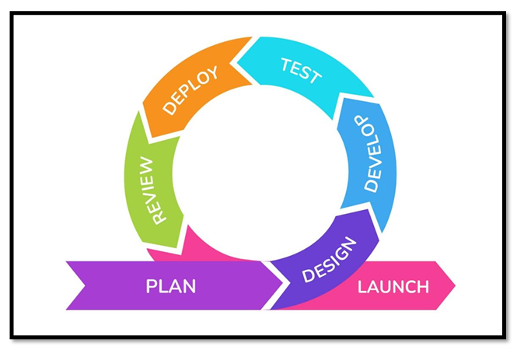
Figure 1: SDLC Cycle

4. DESIGN / IMPLEMENTATION

4.1 BLOCK DIAGRAM
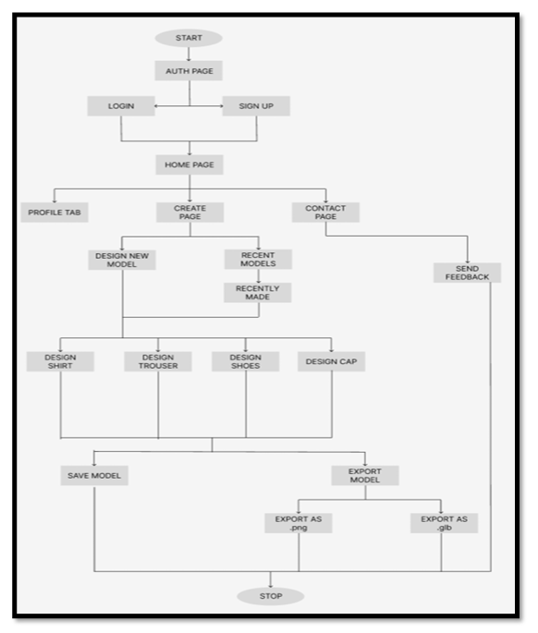
Figure 2: SnX Block Diagram

4.2 SYSTEM ARCHITECTURE DIAGRAM
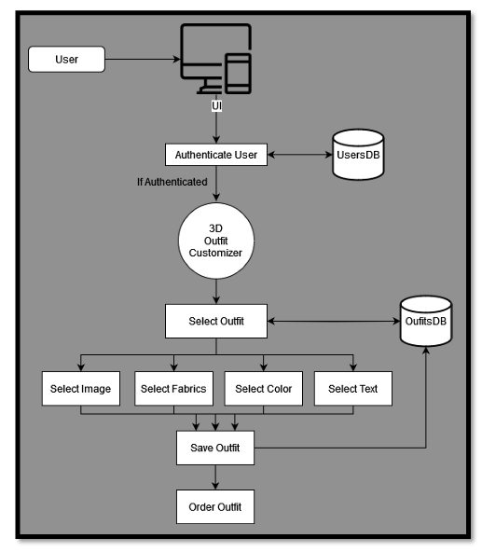
Figure 3: SnX System Architecture

4.3 DATA FLOW DIAGRAM
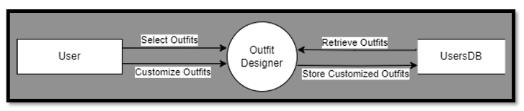
Figure 4: Level 0 for 3D Outfit Customizer

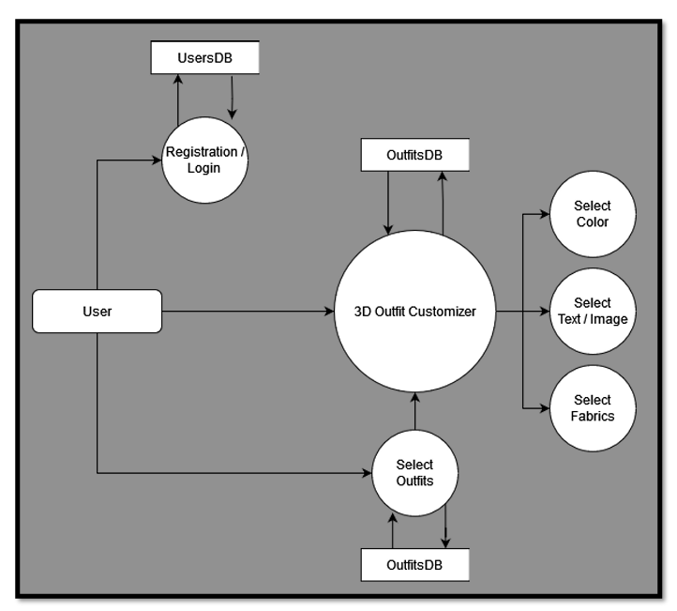
Figure 5: Level 1 for 3D Outfit Customizer

4.4 ER DIAGRAM
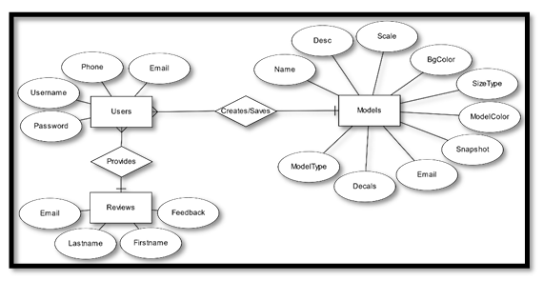
Figure 6: SnX ER Diagram

4.5 SYSTEM WORKFLOW

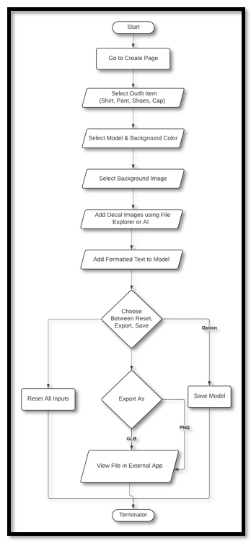
Figure 7: SnX Flow chart

5. HARDWARE AND SOFTWARE REQUIREMENTS

5.1 HARDWARE REQUIREMENTS
The following hardware is recommended for developing and running the SnX: 3D Outfit Customizer:

Component | Minimum Requirement
Processor | Intel Core i5 / AMD Ryzen 5 or equivalent
RAM | 8 GB
Storage | 256 GB SSD
Graphics | Integrated Graphics / Dedicated GPU recommended
Display | 1366 × 768 resolution or higher
Internet | Stable Internet Connection

5.2 SOFTWARE REQUIREMENTS
The following software and technologies are used in the development of the system:

Software | Purpose
Visual Studio Code | Code development and editing
Node.js | JavaScript runtime environment
ReactJS | Frontend development
Next.js | Web application framework
Three.js | 3D rendering and visualization
MongoDB | Database management
Git & GitHub | Version control and code management
Figma | UI/UX design and prototyping

6. TESTING, RESULT AND ANALYSIS

Testing is an essential part of the development of SnX: 3D Outfit Customizer to ensure that the application works reliably and according to its functional requirements. The testing process focuses on verifying user authentication, 3D outfit customization, decal and text addition, AI-generated decals, model saving, resetting, exporting, and retrieval of recently saved models.

The testing process also helps identify and correct software defects and inconsistencies that may affect the performance and usability of the application. Test cases are prepared by defining the required input, expected output, actual output, and test status.

6.1 TESTING METHODOLOGY
The project primarily uses Unit Testing and Functional Testing.

Unit Testing
Unit testing focuses on individual components or functions of the application. It helps verify that each component performs its intended operation before being integrated into the complete system. It also helps identify defects at an early stage and supports easier modification and refactoring of the application.

Functional Testing
Functional testing verifies whether the implemented features satisfy the specified requirements. Test inputs are provided to individual functionalities, and the actual results are compared with the expected results. For SnX, functional testing is performed on important features such as login, customization controls, decal addition, text addition, AI decal generation, model saving, reset, export, and recently saved models.

The general functional testing process consists of:
- Identifying the functionality to be tested.
- Preparing suitable test inputs.
- Defining the expected output.
- Executing the test case.
- Comparing the actual output with the expected result.

6.2 TEST PLAN
The test plan defines the scope and approach used to verify the functionality of SnX. It covers the major user-facing features of the system and establishes the expected results for each test case.

The main areas covered during testing are:
- User login and authentication
- Decal upload and addition
- Text customization
- AI-generated decals
- Reset functionality
- Model saving
- PNG/GLB export
- Recently saved model retrieval
- Session management

6.3 DEBUGGING APPROACH
Debugging was performed whenever a test identified unexpected behavior or an error. The objective of debugging was to identify the cause of the problem and correct it systematically.
The debugging approaches considered include:

- Brute Force Method: Checking intermediate values and program behavior using debugging statements or a source-code debugger.
- Backtracking: Tracing the program backward from the point where an error is observed to identify its possible cause.
- Cause Elimination: Identifying possible causes and conducting tests to eliminate incorrect possibilities.
- Program Slicing: Limiting the debugging search to the parts of the program that can influence a particular variable or operation.

These approaches help isolate errors in the application's authentication, customization, model handling, and export functionalities.

6.4 TEST CASES AND RESULTS

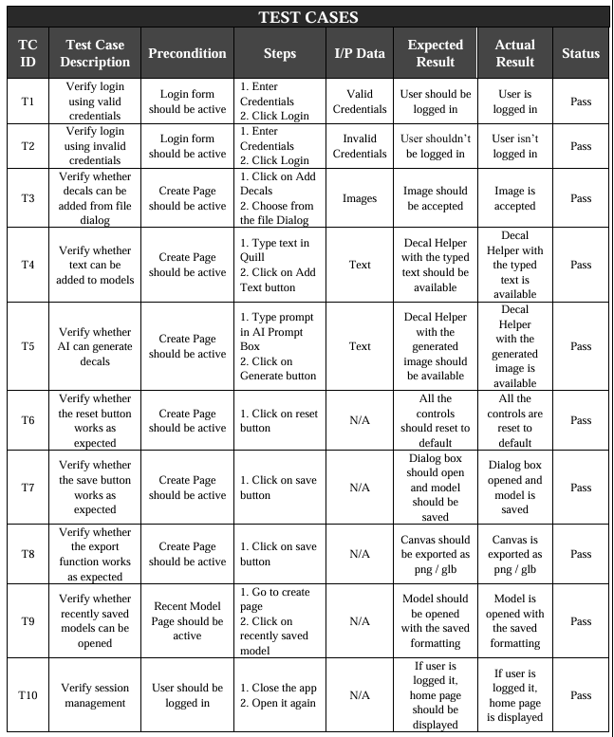

7. SNAPSHOTS

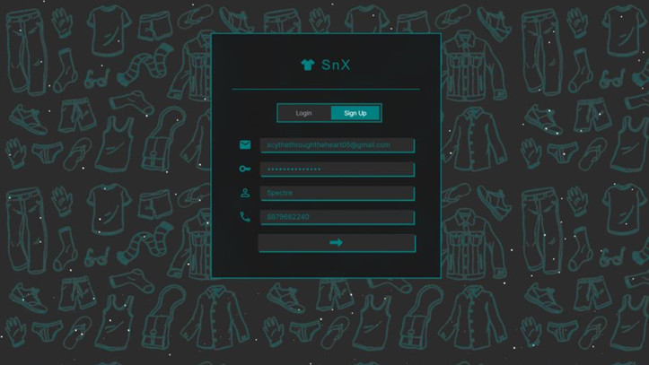
Figure 8: Sign-up Page

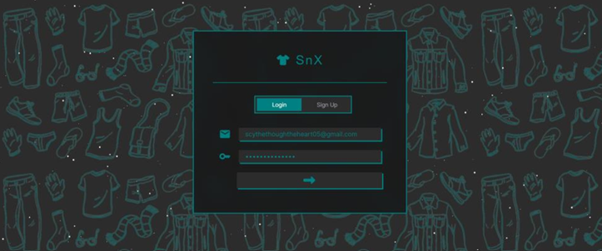
Figure 9: Login Page

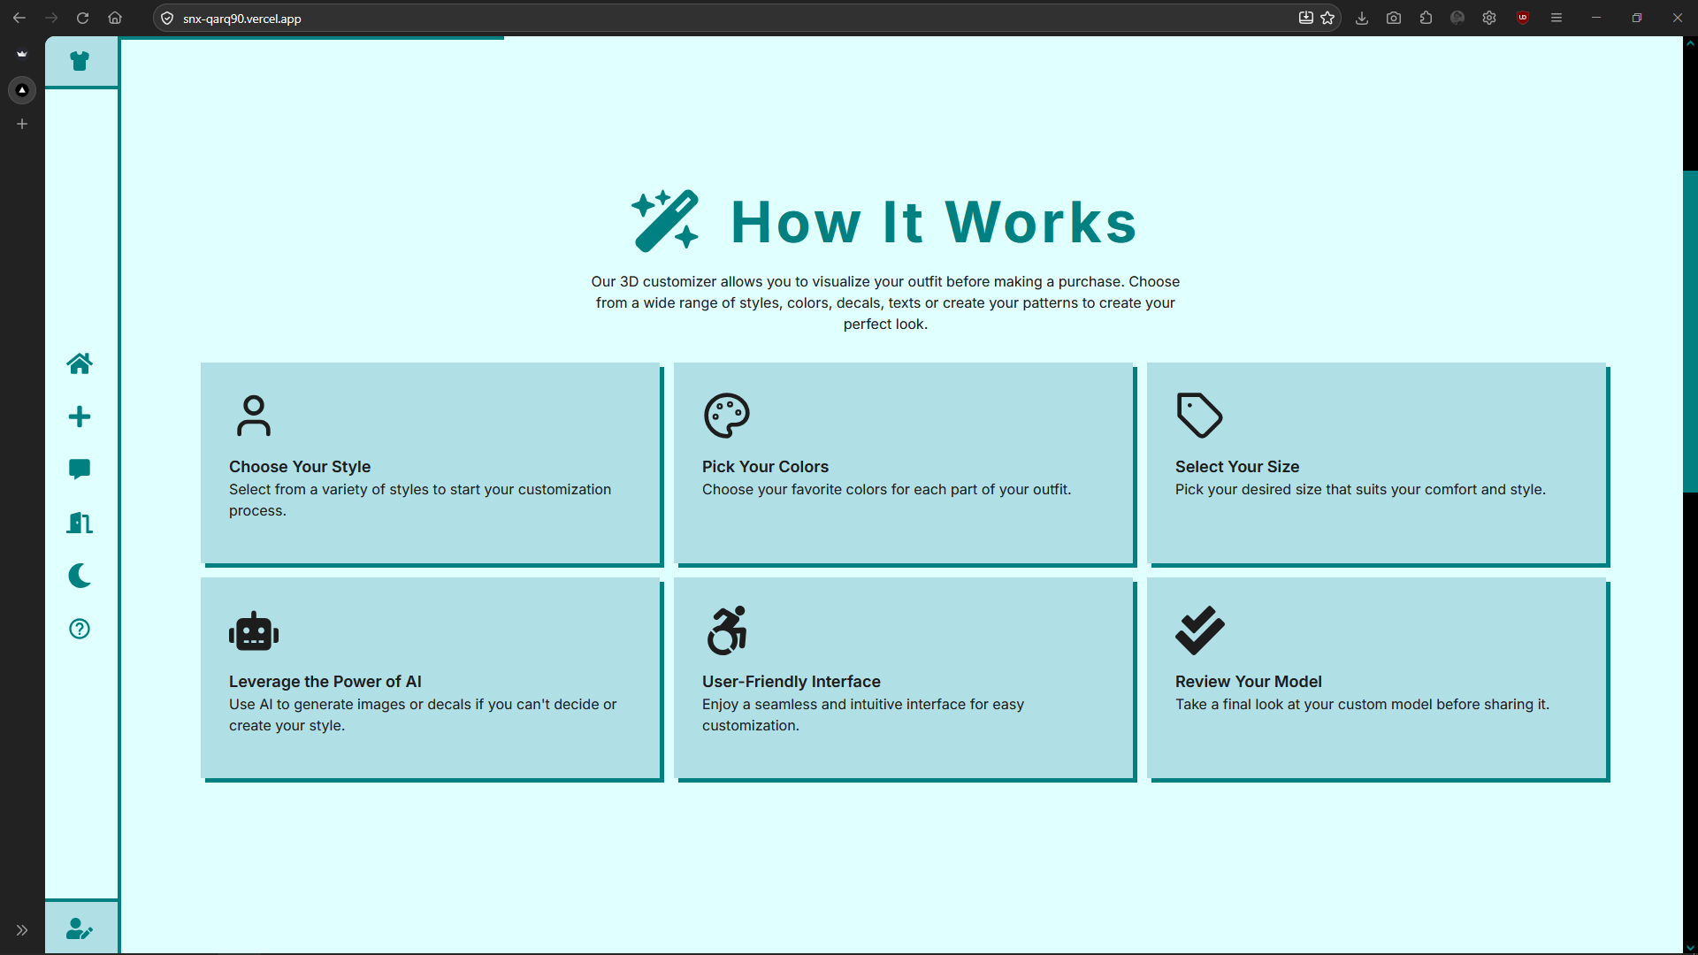
Figure 10: Guiding the users through our application

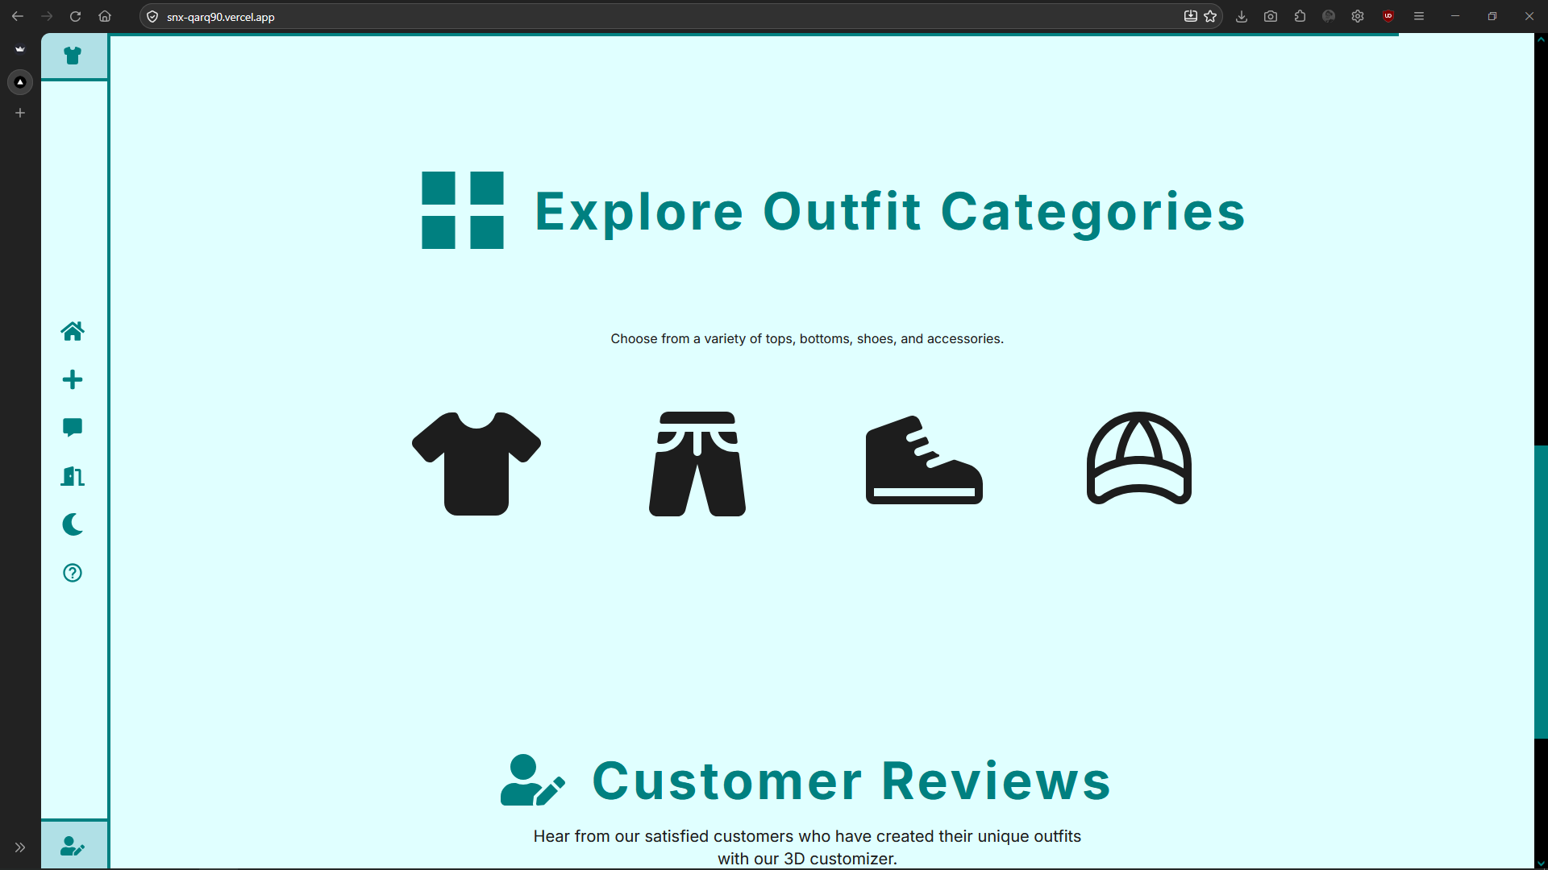
Figure 11: Outfit Categories in SnX

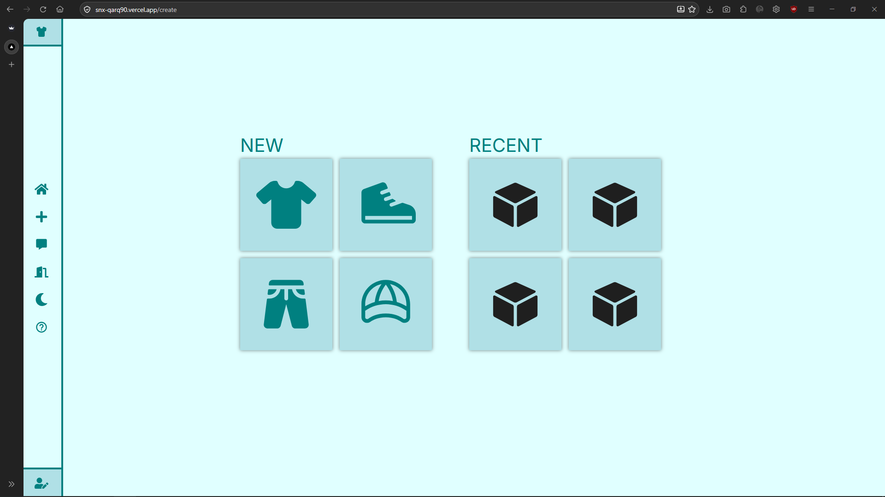
Figure 12: Selecting the Outfit to add style

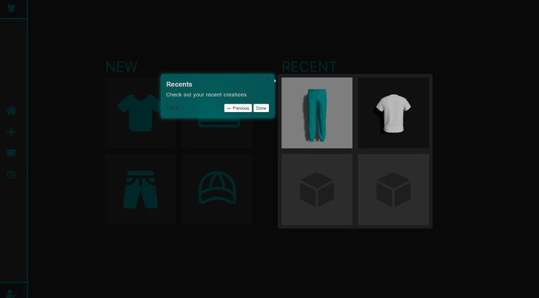
Figure 13: Providing the Navigations using Tooltip to help first time users

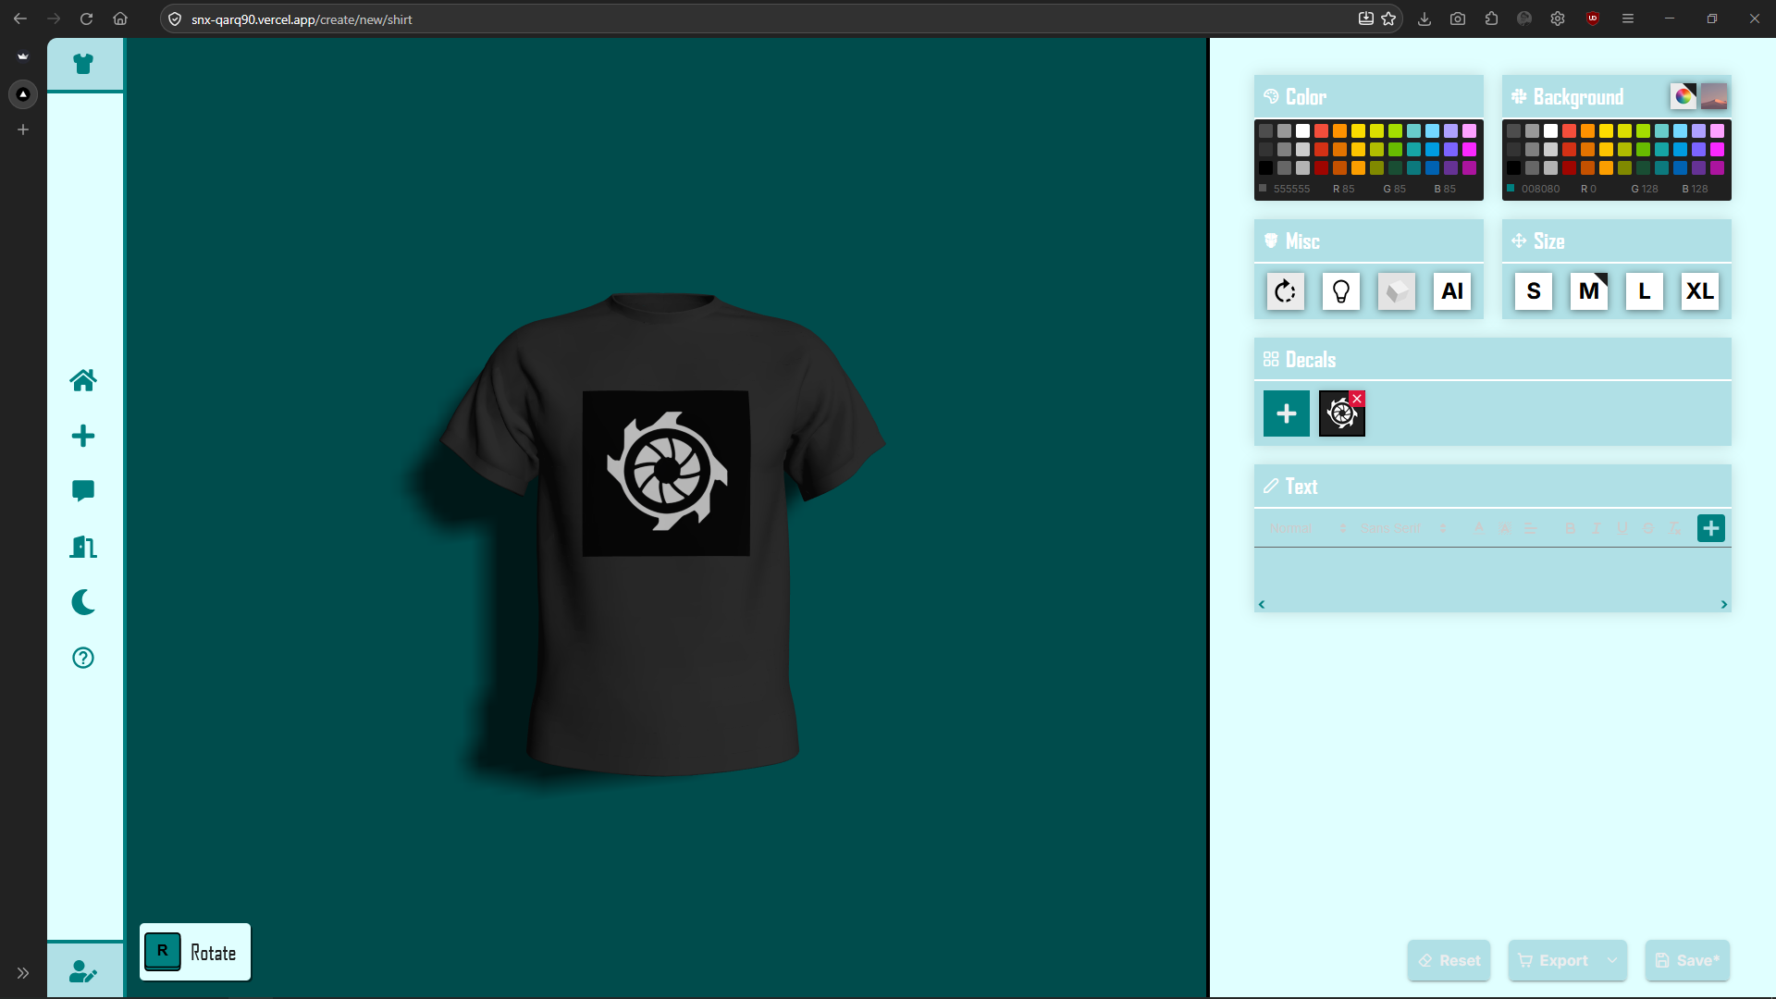
Figure 14: Styling the T-Shirt

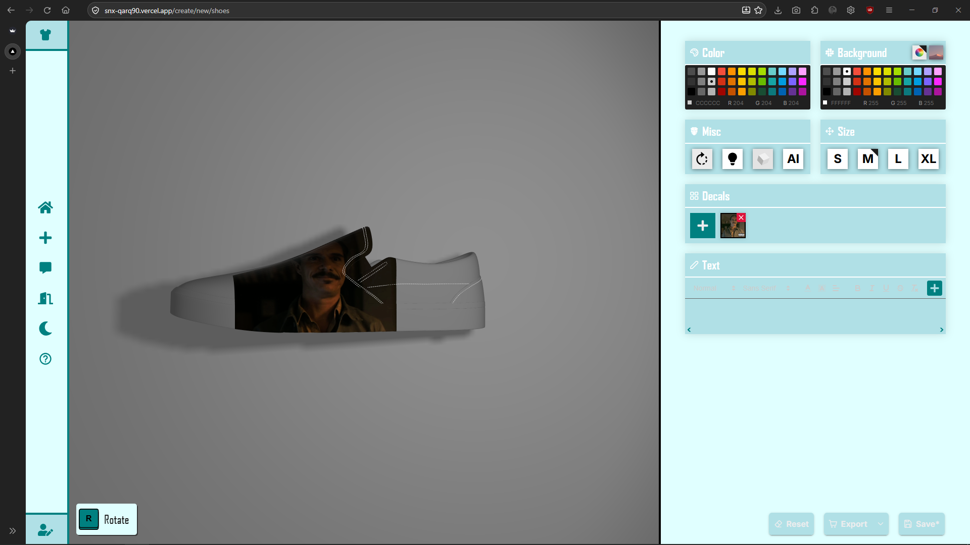
Figure 15: Styling Shoes

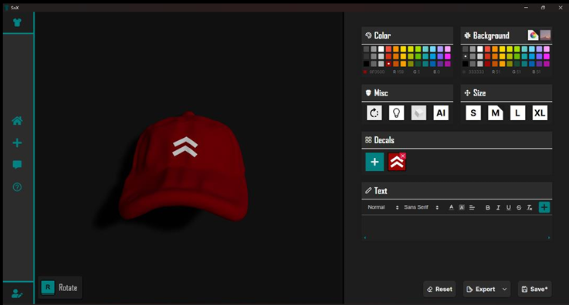
Figure 16: Styling Cap

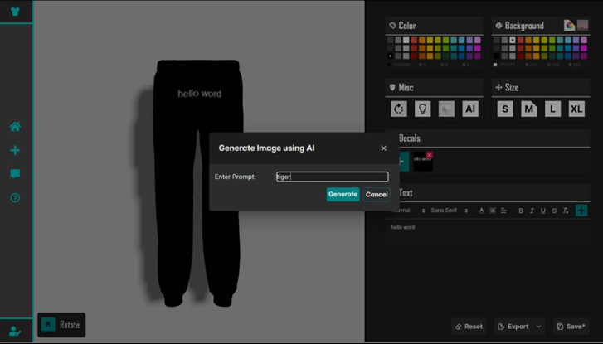
Figure 17: Styling Pants using the AI generated images

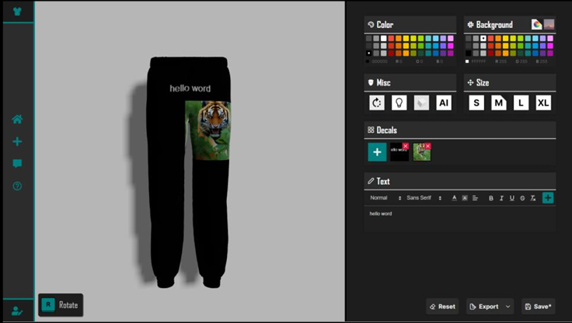
Figure 18: Added Print on the Pants

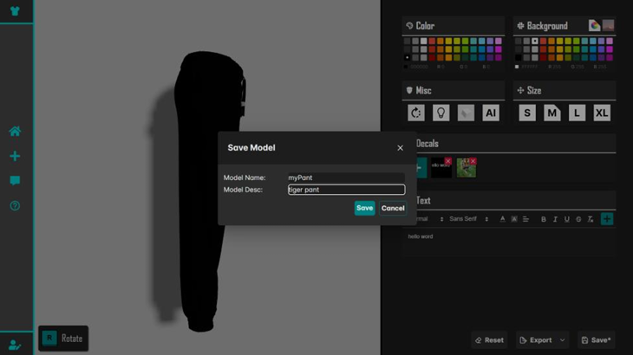
Figure 19: Saving the New design of pant

8. OPEN-SOURCE CONTRIBUTIONS
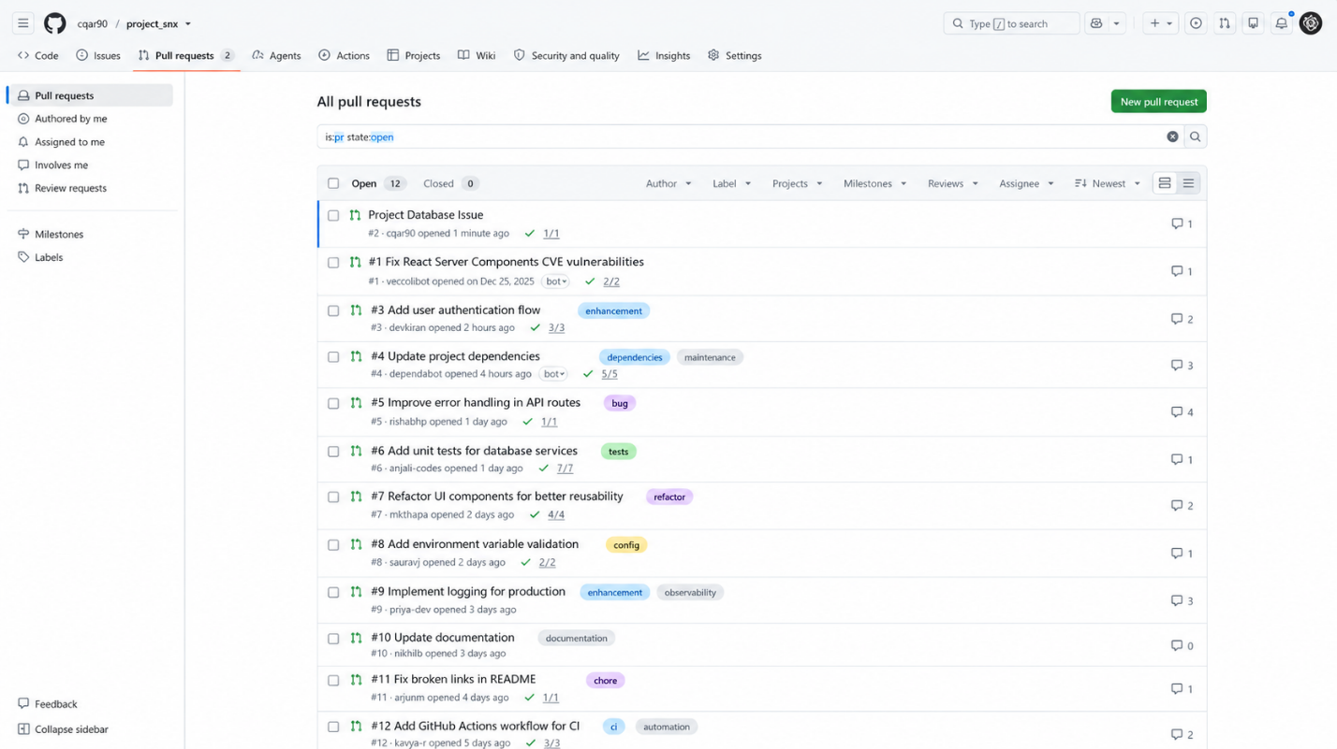

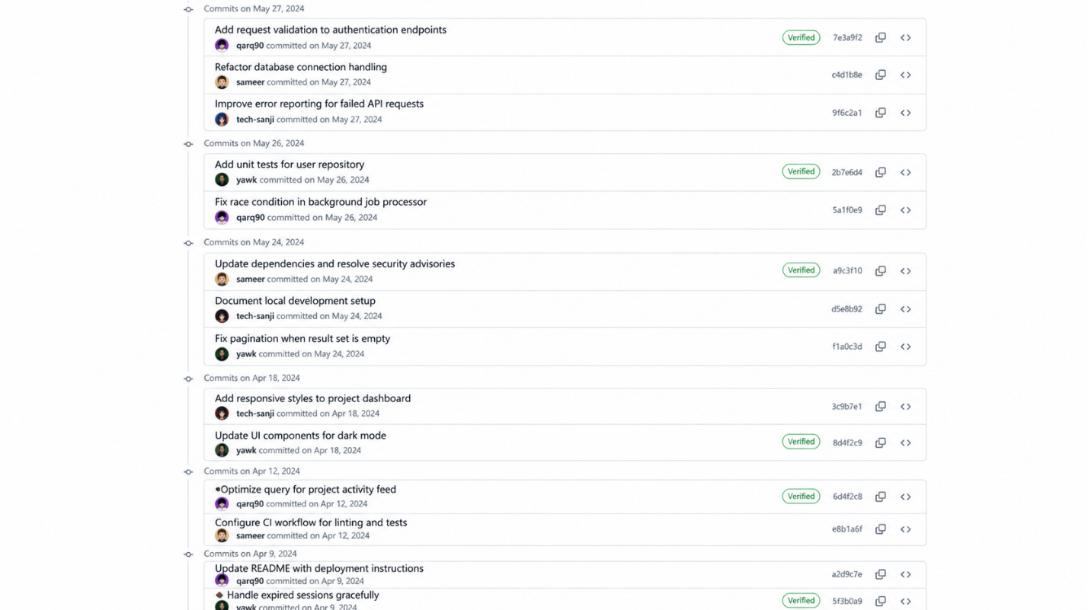

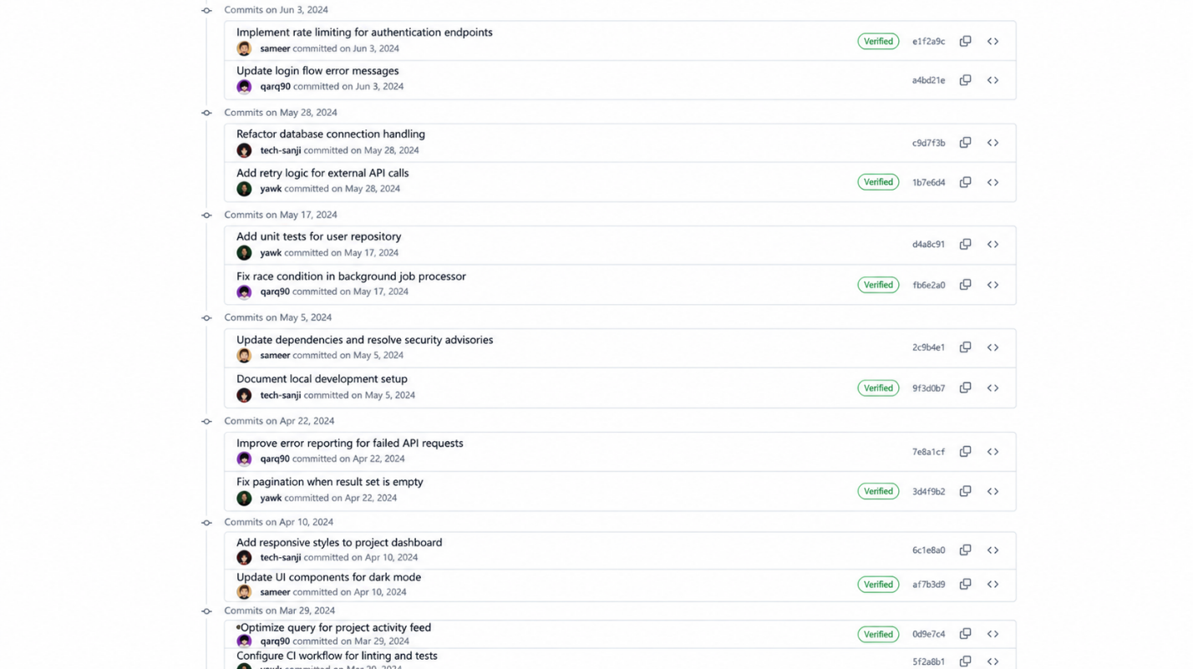

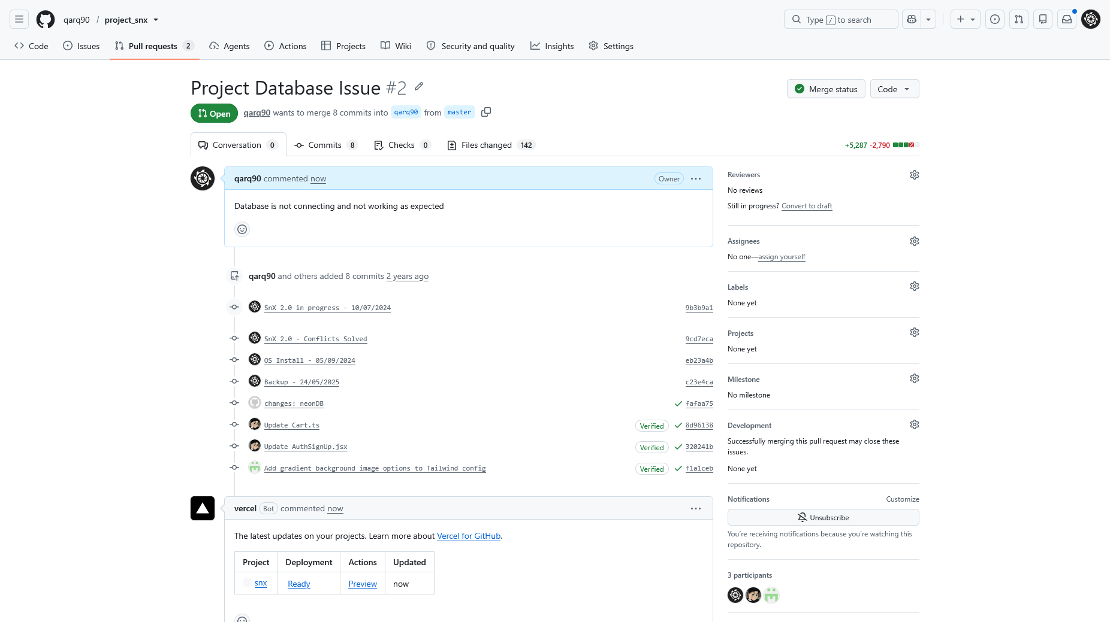

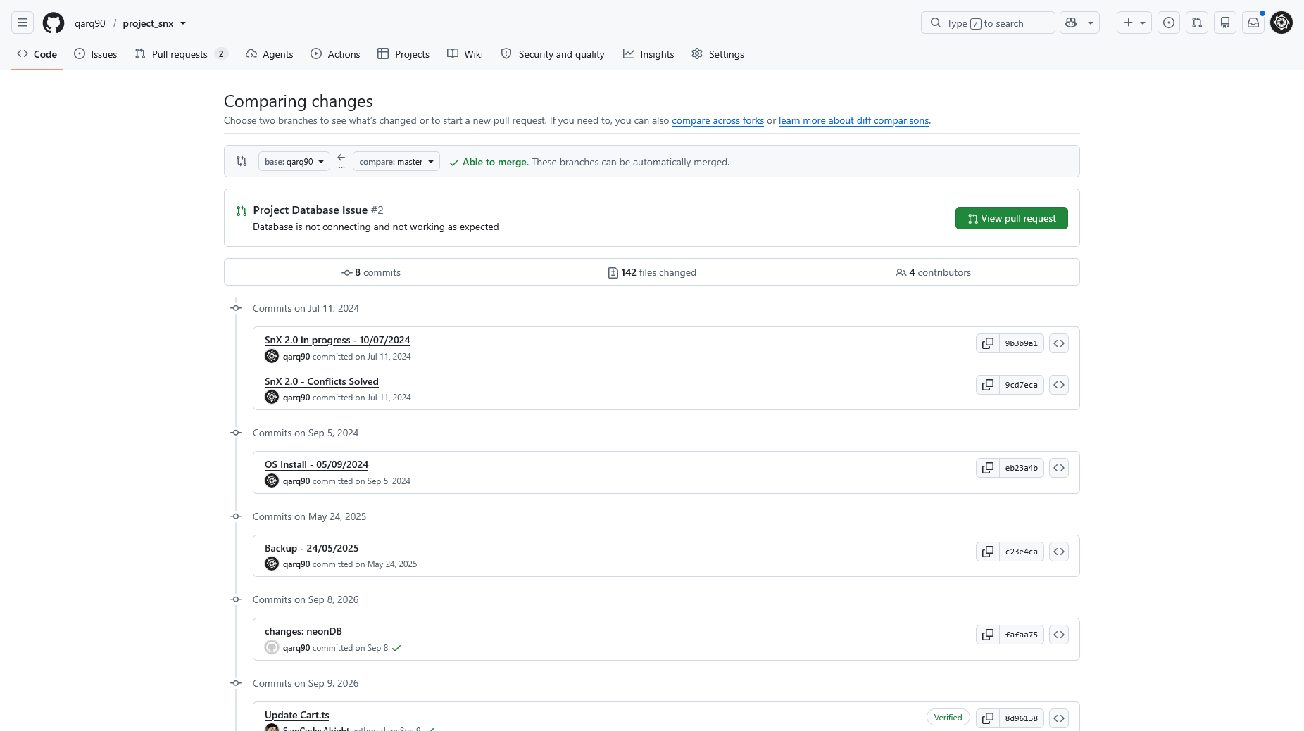

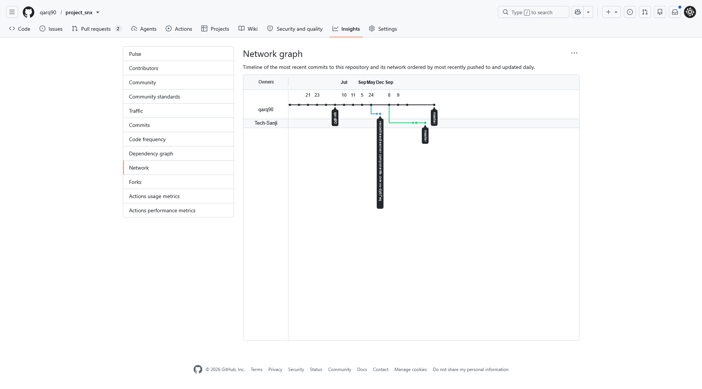

9. TIMELINE CHART

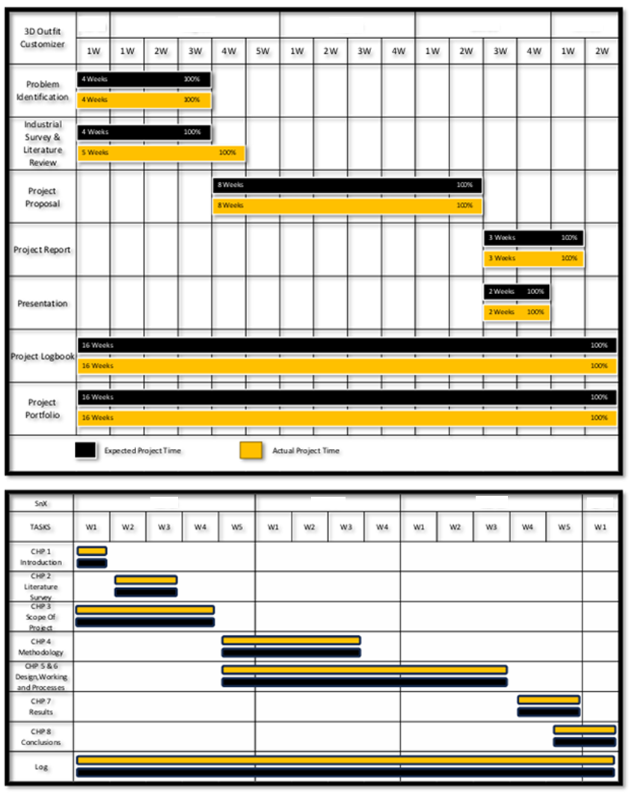

10. FUTURE SCOPE

The SnX: 3D Outfit Customizer can be further enhanced by incorporating advanced technologies and additional features to improve customization, accessibility, and user experience. The major areas of future development are as follows:

9.1 Advanced 3D Modeling:
Advanced 3D modeling techniques can be introduced to create more realistic and detailed outfit models. Improved modeling and rendering can provide users with better visualization of clothing designs, textures, and overall appearance.

9.2 Integration of AR, VR and AI
The platform can be extended with Augmented Reality (AR) and Virtual Reality (VR) technologies to provide a more immersive outfit customization experience. AI can also be further utilized to provide intelligent personalization, style suggestions, and enhanced customization options.

9.3 Enhanced User Interface
The user interface can be continuously improved to make the platform more intuitive, visually appealing, and easier to navigate. Better interaction with the 3D customization tools can provide a smoother and more engaging user experience.

9.4 Fashion Brand and Designer Integration
SnX can collaborate with fashion brands, designers, and industry influencers to introduce exclusive collections, current fashion trends, and personalized style recommendations. Such integration can provide users with a wider range of professional and premium outfit options.

9.5 Overall Future Development
In the future, SnX can evolve from a 3D outfit customization platform into a more comprehensive interactive digital fashion platform by combining advanced 3D modeling, AR/VR, AI-based personalization, mobile accessibility, and collaboration with fashion professionals. These enhancements can improve both the functionality of the system and the overall user experience.

11. CONCLUSION

The SnX: 3D Outfit Customizer provides an interactive approach to online fashion by allowing users to create, customize, and visualize outfits in a 3D environment. The system combines modern web technologies such as ReactJS, Next.js, Three.js, React Three Fiber, and MongoDB to provide a user-friendly customization platform.

The implemented features allow users to customize clothing items, add colors, text, decals, and AI-generated images, save and retrieve models, reset customizations, and export models in PNG and GLB formats. The testing results demonstrate that the major functionalities of the system operate as expected.

Overall, SnX demonstrates the potential of 3D web-based customization to provide a more interactive and personalized fashion experience. With future enhancements such as AR/VR, advanced AI, improved 3D modeling, mobile applications, and fashion brand integration, the platform can be further developed into a comprehensive digital fashion solution.

12. REFERENCES

[1] M. Stanton, T. Hartley, F. Loizides, and A. Worrallo, “Dual-Mode User Interfaces for Web-Based Interactive 3D Virtual Environments Using Three.js,” 2017.

[2] P. S. Maratkar and P. Adkar, “React JS – An Emerging Frontend JavaScript Library,” 2021.

[3] A. Rananavare, “Frontend Development with React.js,” 2022.

[4] H. A. Jartarghar, G. R. Salanke, A. K. A. R., S. G. Sharvani, and S. Dalali, “React Apps with Server-Side Rendering: Next.js,” 2022.

[5] A. K. Srivastava, V. Laxmi, P. Singh, K. Pratima, and V. Kirti, “React JS (Open Source JavaScript Library),” 2022.

[6] B. V. S. Indla and Yogeshch, “Modern Web-Development Using React.js,” 2018.

[7] D. Bansal, “Review on React JS,” 2020.

[8] G. Jadhav and F. Gonsalves, “Role of Node.js in Modern Web Application Development,” 2020.

[9] S. G. V. and A. Sandeep, “Comprehensive Analysis of React-Redux Hybrid App Development Framework,” 2020.

[10] Y. Patil and K. Wanjale, “Survey and Analysis of Rendering Realtime 3D Object on Cross-Browser & Cross-Platform Using WebGL,” 2020.

[11] T. N. Eicke, Y. Jung, and A. Kuijper, “Robust Real-Time Shadows for Dynamic 3D Scenes on the Web,” 2014.

[12] M. Li and C. Li, “Movie Data Visualization Based on WebGL,” 2021.

